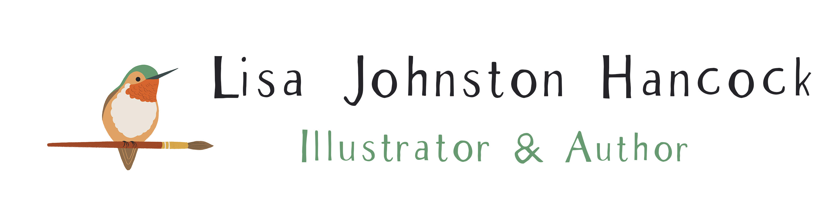

Lisa Johnston Hancock was an art teacher for many years, teaching both kids and adults before she became a full time illustrator and author. In her spare time, she hosts a You Tube channel with a focus on art education. Lisa also write musings on her new Substack page, The Curious Illustrator.
When she is not making art, you can find her stargazing, hiking, reading, tinkering with her bass guitar or relaxing outside, watching the hummingbirds and bees pollinate the garden. Lisa has felt a connection to the natural world for as long as she can remember. As a child, she has fond memories of exploring her family’s farm by day and looking for Ursa Major by night. Today, Lisa loves pointing out the constellations to her children when they are far away from city lights.
Santiago and Great Bear is Lisa's debut picture book as both an illustrator and author. Originally from Mobile, Alabama, Lisa now calls the Los Angeles area home, where she lives with her family.

